**Filtering out videos uploaded before 2019**

MATCH (video:VIDEO)

WHERE date(datetime(video.upload_date))> date(datetime({year:2019,month:1,day:1}))

RETURN video

**With misinformative videos**

MATCH (video:VIDEO)

WHERE date(datetime(video.upload_date))> date(datetime({year:2019,month:1,day:1})) AND video.is_known_misleading = true

RETURN video

**Channels posting misinformative videos and to see which videos these misinformative video recommends**

MATCH (c:CHANNEL) -[r:UPLOADED] - (video:VIDEO) -[r1:RECOMMENDED_RESULT]-(n)-[r2:RECOMMENDED_RESULT]-(m:VIDEO)

WHERE date(datetime(video.upload_date))> date(datetime({year:2019,month:1,day:1}))

and video.is_known_misleading=true

RETURN c,r,video,r1,r2,m,n LIMIT 50

**Channels posting misinformative videos recommends misinformative videos and hashtags associated with it**

MATCH (c:CHANNEL) -[r:UPLOADED] - (video:VIDEO) -[r1:RECOMMENDED_RESULT]-(n)-[r2:RECOMMENDED_RESULT]-(m:VIDEO)-[r3:MENTIONS]-(h:HASHTAG)

WHERE date(datetime(video.upload_date))> date(datetime({year:2019,month:1,day:1}))

and video.is_known_misleading=true and m.is_known_misleading=true

RETURN c,r,video,r1,r2,m,n,r3,h LIMIT 100

MATCH (v:CHANNEL)-[r:UPLOADED]-(h:VIDEO)

WHERE h.likes >200 and h.is_known_misleading=true

and date(datetime(h.upload_date))> date(datetime({year:2019,month:1,day:1}))

RETURN v,r,h

**To delete a relation between 2 nodes**

MATCH (video:VIDEO)-[r:RECOMMENDED_RESULT]->()

DELETE r

**To see recommended results of misinformative videos**

MATCH (c:CHANNEL) -[r:UPLOADED] - (video:VIDEO) -[r1:RECOMMENDED_RESULT]-(n)

WHERE date(datetime(video.upload_date))> date(datetime({year:2019,month:1,day:1}))

and video.is_known_misleading=true

RETURN c,r,video,r1,n LIMIT 100

**To see misleading videos along with the channels that uploaded them**

MATCH (c:CHANNEL) -[r:UPLOADED] - (video:VIDEO)

WHERE WHERE date(datetime(video.upload_date))> date(datetime({year:2019,month:1,day:1}))

and video.is_known_misleading=true

RETURN c,r,video LIMIT 25

**To see filtered video and recommended videos with name like -----**

MATCH (video:VIDEO)-[r:RECOMMENDS]-(m)

WHERE date(datetime(video.upload_date))> date(datetime({year:2019,month:1,day:1}))

and video.title =~ '.*parasites.*'

RETURN video,r,m limit 25

**To see misleading videos which have hashtags**

MATCH (video:VIDEO) -[r1:MENTIONS]-(h:HASHTAG)

WHERE date(datetime(video.upload_date))> date(datetime({year:2019,month:1,day:1}))

and video.is_known_misleading=true

RETURN video,r1,h limit 25

--------------------

----------

MATCH p=()-[r:RECOMMENDED_RESULT]->() RETURN p limit 500

MATCH p=()-[r:SEARCH_RESULT]->() RETURN p LIMIT 700

**Results**

-------------------

**Result 1: All misleading videos recommend misleading videos**

**Result 2: We can see that almost all misinformative videos recommend video** **“Parasiten in PCR Test-....”**

MATCH (c:CHANNEL) -[r:UPLOADED] - (video:VIDEO)

WHERE date(datetime(video.upload_date))> date(datetime({year:2019,month:1,day:1}))

and video.is_known_misleading=true

RETURN c,r,video LIMIT 100

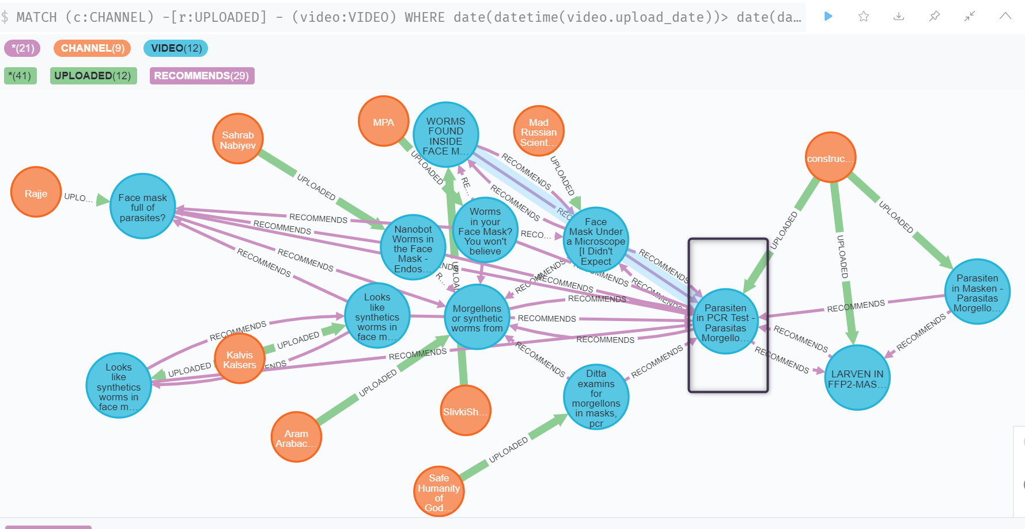

**Result 2: The 2 misinformative videos of channel Kalvis Kalsers recommend each other and the other first recommended videos also lead to these 2 misinformative videos only**

MATCH (c:CHANNEL) -[r:UPLOADED] - (video:VIDEO) -[r1:RECOMMENDED_RESULT]-(n)-[r2:RECOMMENDED_RESULT]-(m:VIDEO)

WHERE date(datetime(video.upload_date))> date(datetime({year:2019,month:1,day:1}))

and video.title=~'.*Looks like synthetics worms.*'

and video.is_known_misleading=true

RETURN c,r,video,r1,r2,m,n

----------------

MATCH (c:CHANNEL) -[r:UPLOADED] - (video:VIDEO) -[r1:RECOMMENDED_RESULT]-(n)-[r2:RECOMMENDED_RESULT]-(m:VIDEO)

WHERE date(datetime(video.upload_date))> date(datetime({year:2019,month:1,day:1}))

and video.is_known_misleading=true

and n.position=1

RETURN c,r,video,r1,r2,m,n LIMIT 50